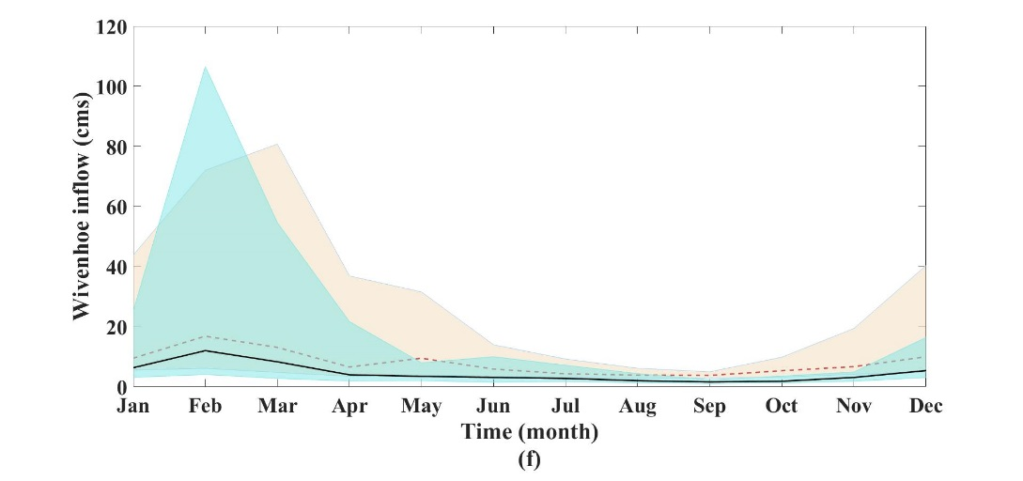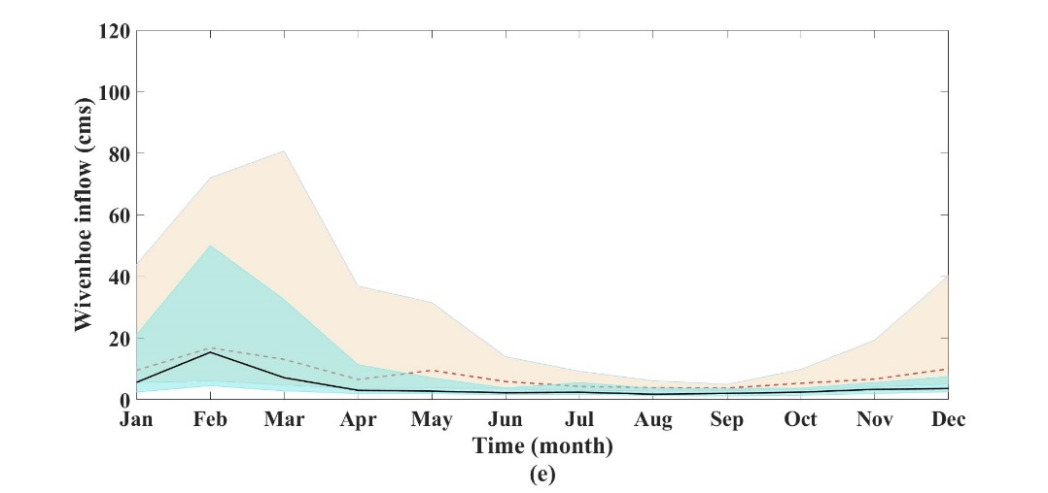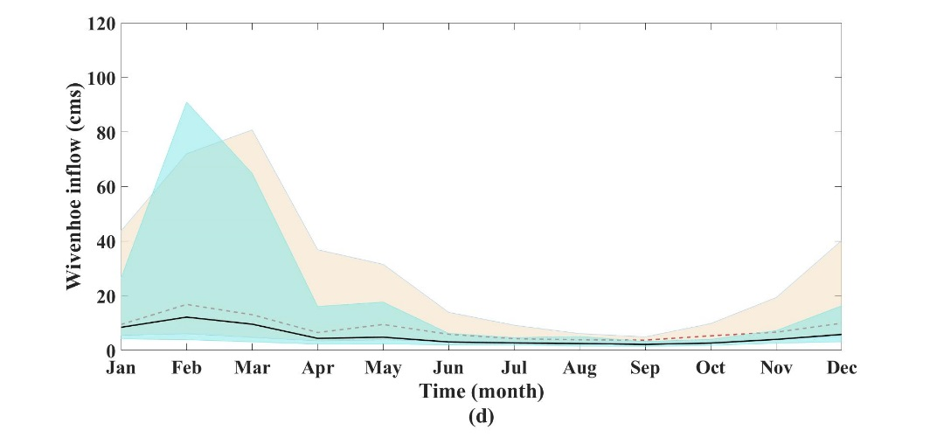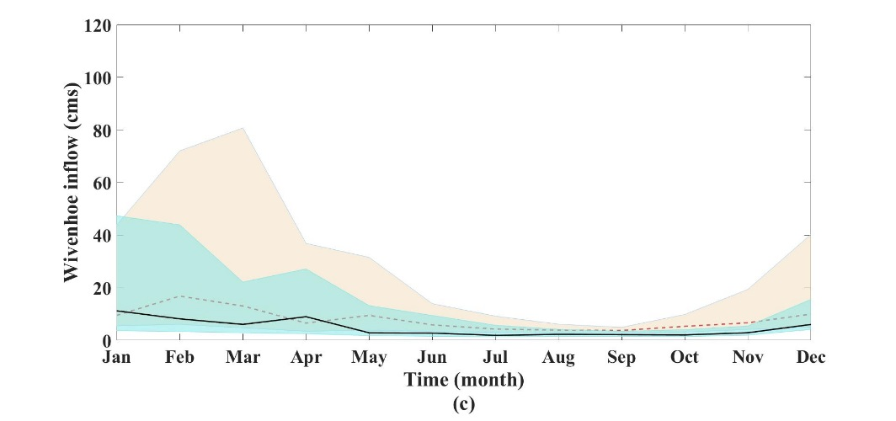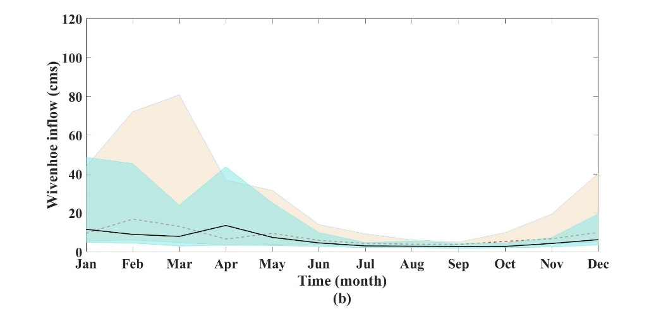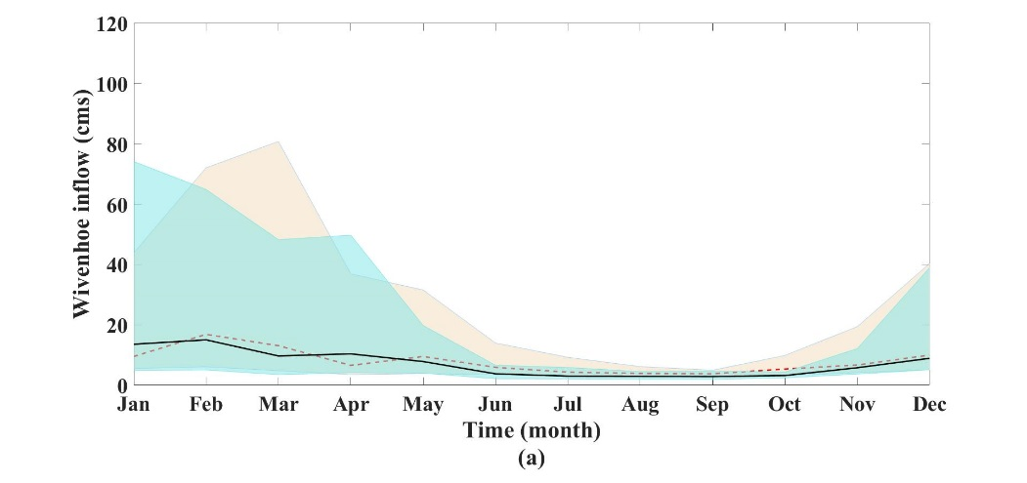

Comparison of ensemble inflow projections and baseline inflow of Wivenhoe over the (a) near future – RCP4.5, (b) mid future – RCP 4.5, (c) far future – RCP 4.5, (d) near future – RCP 8.5, (e) mid future – RCP 8.5 and (f) far future – RCP 8.5



Baseline

Projection

75%

25%

75%

25%

Median

Median